**Master Functional Ducument**

|  |  |
| --- | --- |
| **Application** | NGERP - Centra |
| **Service Bundle** | Master Management |
| **Service Request** | Tax Category |

**Description :**

Tax Category Master is Used to Create Tax Category.

**Workflow Process :**

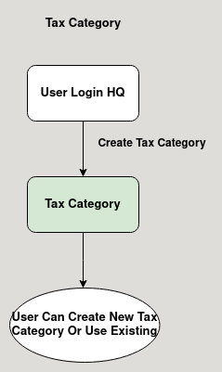

**Business Rules :**

* The Tax Category Master is used to create tax category.
* Tax Category can be only created in HQ.
* Tax Category should be Active to show in the tax category list.
* Tax Category Must be assigned to Tax Rate to calculate Tax.